**Linear Classification: Logistic Regression**

Despite being called a regression method this is actually used for classification. This is a generalized linear model. As this is classification the output is a binary value either 0 or 1, these values are then assigned to target values, e.g. apples or oranges.

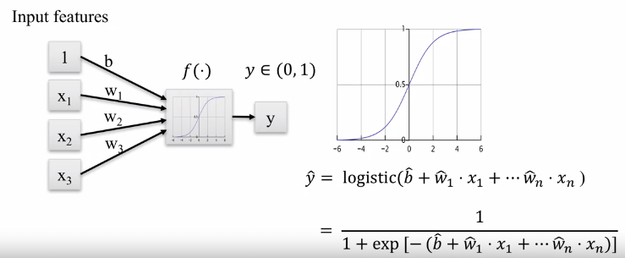

The logistic regression makes use of the sigmoid function and a linear model to predict the target values. The way this function works is base on probability, if the output of the function is <0.5 then the value is 0 else it is 1.

**The limits of this function are always 0-1.**

e.g. trying to estimate if students will pass a test based only on hour studied:

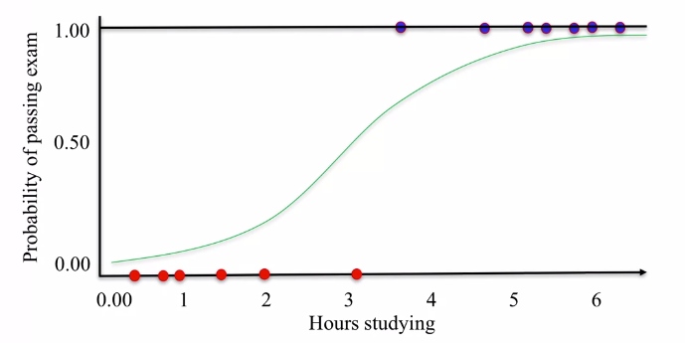

e.g. A higher dimension problem:

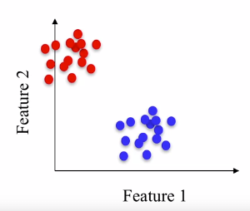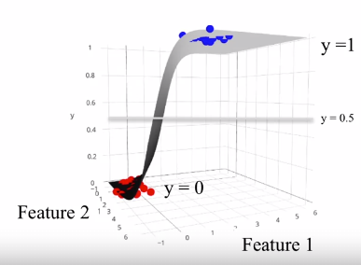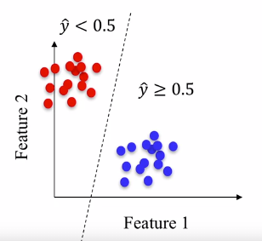

The left most figure shows a dotted line which can be thought of as the **decision boundary**.

**Parameter C:**

Similarly, to ridge regression a **L2 is used a default**. The parameter **C** controls the amount of regularization the model has. With higher values of C less regularization occurs, this is the opposite of above.

* **High values of C the model tries to fit the training data as well as it can.**
* **Low values of C the model tries to generalize better to new data points.**

**(same C effect for SVMs)**

